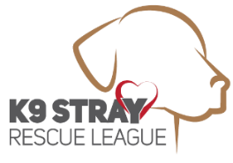**Owner Surrender Interview Form**

Why do you need to surrender the dog?

Has the dog every shown aggression towards people or dogs?

Has the dog ever bitten anyone?

***K9 Stray Rescue League completes a behavioral evaluation on all dogs before intake and if there is any aggression, we are unable to take the dog.***

What is the breed, sex and approximate weight?

How old is the dog?

Has the dog been spay/neutered?

Is the dog up to date on its rabies and distemper vaccines?

Is the dog on monthly heartworm preventative?

Does the dog have any know medical issues?

What is the name and phone # of the Veterinarian the dog has last seen?

What is the current home situation  
 Number of adults in the home?  
 Number of children in the home and their ages?  
 Any other animals in the home?  
 Is the dog kept outside for any length of time and if so how is it currently contained?

Owner Surrender Name:

Email: Phone Number:

*I give K9 Stray Rescue League permission to contact my Veterinarian (initials here) ______*

INSTRUCTIONS: Save this document to your computer and answer all questions. Then attach and email this document to [k9strayrescue@yahoo.com](mailto:k9strayrescue@yahoo.com). We will respond to your request within 1-3 days.